**Classroom Activity: Write a program to create a library management system using a base class for different types of books.**

**Code:**

|  |
| --- |
| // Base class for books  class Book {  constructor(title, author, isbn) {  this.title = title;  this.author = author;  this.isbn = isbn;  }    getDetails() {  return `${this.title} by ${this.author}, ISBN: ${this.isbn}`;  }  }    // Derived class for Fiction books  class Fiction extends Book {  constructor(title, author, isbn, genre) {  super(title, author, isbn);  this.genre = genre;  }    getDetails() {  return `${super.getDetails()}, Genre: ${this.genre}`;  }  }    // Derived class for Non-Fiction books  class NonFiction extends Book {  constructor(title, author, isbn, subject) {  super(title, author, isbn);  this.subject = subject;  }    getDetails() {  return `${super.getDetails()}, Subject: ${this.subject}`;  }  }    // Derived class for Reference books  class Reference extends Book {  constructor(title, author, isbn, field) {  super(title, author, isbn);  this.field = field;  }    getDetails() {  return `${super.getDetails()}, Field: ${this.field}`;  }  }    // Library class to manage books  class Library {  constructor() {  this.books = [];  }    addBook(book) {  this.books.push(book);  }    listBooks() {  return this.books.map(book => book.getDetails()).join('\n');  }    findBook(isbn) {  return this.books.find(book => book.isbn === isbn);  }  }    // Create a new library  const library = new Library();    // Add books to the library  const book1 = new Fiction('The Great Gatsby', 'F. Scott Fitzgerald', '9780743273565', 'Classic');  const book2 = new NonFiction('Sapiens', 'Yuval Noah Harari', '9780062316097', 'History');  const book3 = new Reference('Encyclopedia of Science', 'DK', '9781465462426', 'Science');    library.addBook(book1);  library.addBook(book2);  library.addBook(book3);    // List all books in the library  console.log('Books in the library:');  console.log(library.listBooks());    // Find a book by ISBN  const isbnToFind = '9780062316097';  const foundBook = library.findBook(isbnToFind);  console.log(`\nFound book with ISBN ${isbnToFind}:`);  console.log(foundBook ? foundBook.getDetails() : 'Book not found'); |

**Output:**

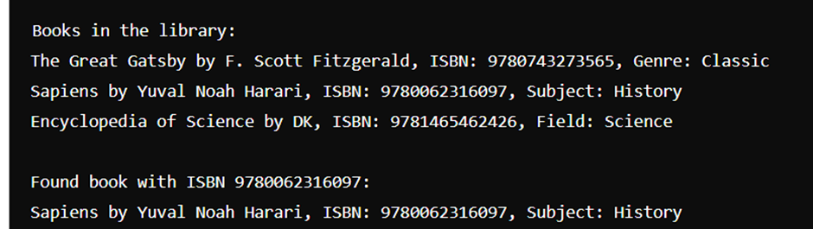

**Execution-Steps:**

* Create a JavaScript file with any name
* Write the code
* Run the code in the terminal using F5 or right click and go to inspect and you can get the output in the console as well.